a
 | 7.1.35 Editors - 3D Viewport - Header - Grease Pencil - Weight Paint Mode - Weights Menu
Table of content
Weight Paint Mode - Weights Menu 1
Normalize All 1
Last Operator Normalize all Vertex Group 1
Lock Active 1
Normalize 1
Invert 1
Smooth 2
Last Operator Smooth Vertex Group 2
Factor 2
Iterations 2
Sample Weight 2

Weight Paint Mode - Weights Menu

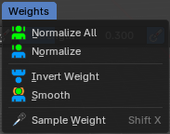

Normalize All
Normalizes the weight of all Vertex groups so that the values for the single vertices in the sum is 1.

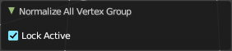
Last Operator Normalize all Vertex Group

Lock Active
Keep the values of the active group while normalizing others.

Normalize
Normalize normalizes the weight of the current selected Vertex group so that the values for the single vertices in the sum is 1. Means when there is influence from other groups, then those values are kept, but the one for the current group gets lowered so that the sum is 1.

Invert
Invert inverts the weight painting for the selected vertex group.

Smooth
Smooths the weight for selected vertices.

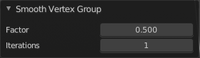
Last Operator Smooth Vertex Group

Factor
Here you adjust the factor.

Iterations
Here you adjust how many iterations you use.

Sample Weight
Pick the weight under the mouse by a click.

